GLY 4310C
LAB 10 METAMORPHIC ROCKS, PART 2
HIGHER-GRADE REGIONAL METAMORPHICS
Gneiss and Eclogite
The sillimanite-garnet gneiss shows only vague foliation, while the granitoid gneiss shows none.
Rocks of this type are transitional to, or part of, the granulite facies. The granulite facies is the highest grade of regional metamorphic rocks which are not formed under extreme pressure. Beyond the granulite facies rocks begin to melt and become igneous.
Quartzo-feldspathic matrix - 30%,
Almandine-15%,
Ilmenite-10%
Sillimanite- 45%
For more information: https://micro.magnet.fsu.edu/primer/techniques/polarized/gallery/pages/sillimanitegarnetgneisssmall.html
https://www.virtualmicroscope.org/content/garnet-sillimanite-gneiss-isle-harris
Sample 81. Sillimanite-garnet gneiss
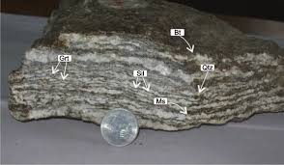
Close-up view of hand-specimen of Darjeeling gneiss showing
garnet (Grt), sillimanite (Sl) and biotite (Bt), Muscovite (Ms), Quartz (Qtz).

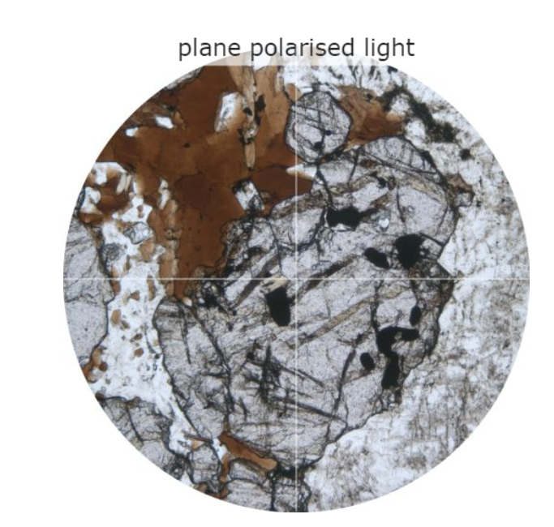
Sillimanite-garnet gneiss under PPL showing biotite.
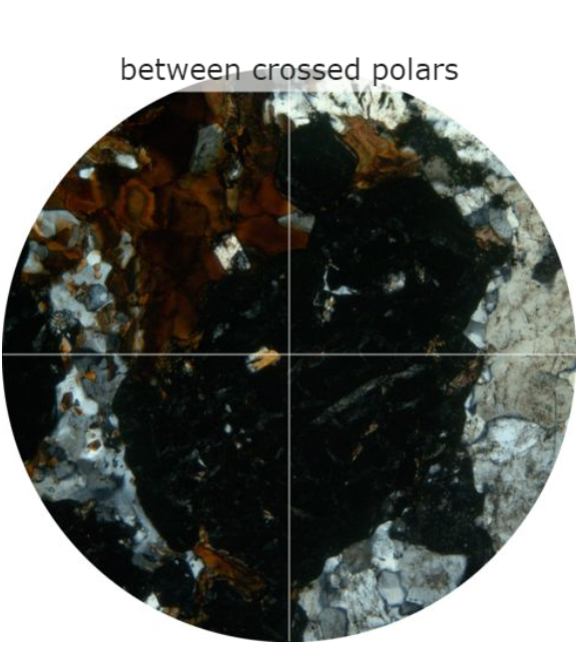
Sillimanite-garnet gneiss under XPL

Sample 89. Augen gneiss
FAIR GNEISSIC LAYERING XENOBLASTIC, Medium to coarse grained Both plagioclase and biotite display trachytoid behavior around the augen.

Plagioclase feldspar: 35%
Quartz: 10%
K-spar: 38%
Biotite: 25%

For more information: https://micro.magnet.fsu.edu/primer/techniques/polarized/gallery/pages/augengneisssmall.html
https://www.alexstrekeisen.it/english/meta/augengneiss.php
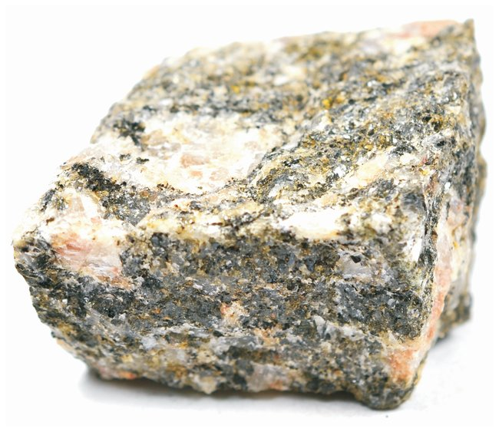

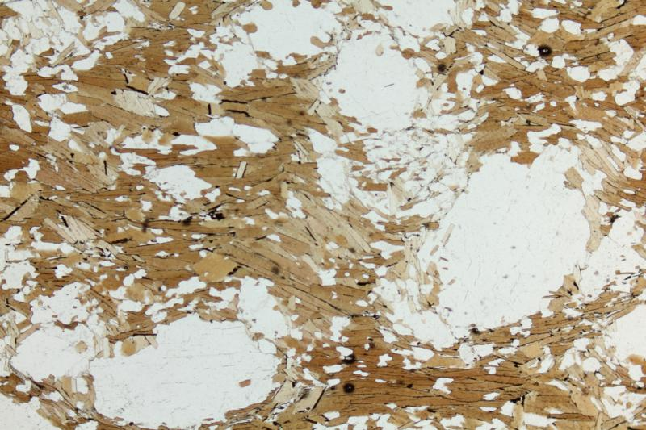
Feldspar Augen, borded by Biotite, in a deformed graundmass in a Gneiss. PPL image, 2x (Field of view = 7mm)
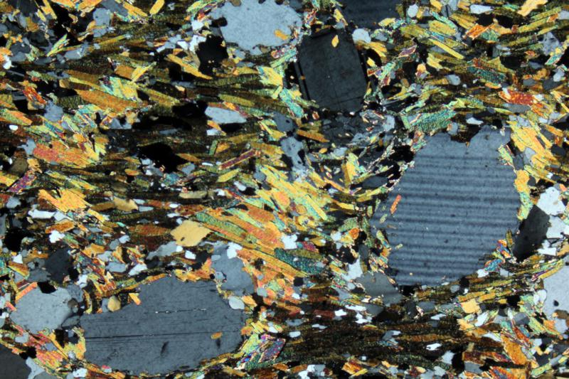
Feldspar Augen, borded by Biotite, in a deformed graundmass in a Gneiss. XPL image, 2x (Field of view = 7mm)

Sample 90. Granitoid gneiss
Granitoid gneiss have no foliation. Granitoid gneiss are close to granite in composition and, sometimes, in appearance. Granitoid gneiss is a variety of metamorphic gneiss that appears to have bands of black and white minerals such as feldspar and mica. These bands form from the heating and squeezing of the rock although, granitoid gneiss may look very similar to the original granite rock. Granitoid gneiss is medium- to coarse-grained and occurs around the world.

Plagioclase feldspar: 27-37%
Quartz: 10%
K-spar: 40-50%
Magnetite: 10%

For more information:
https://www.youtube.com/watch?v=qmeL9Cz_Jeg

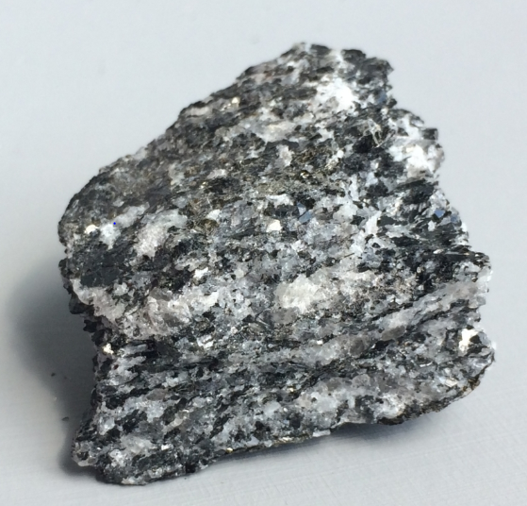
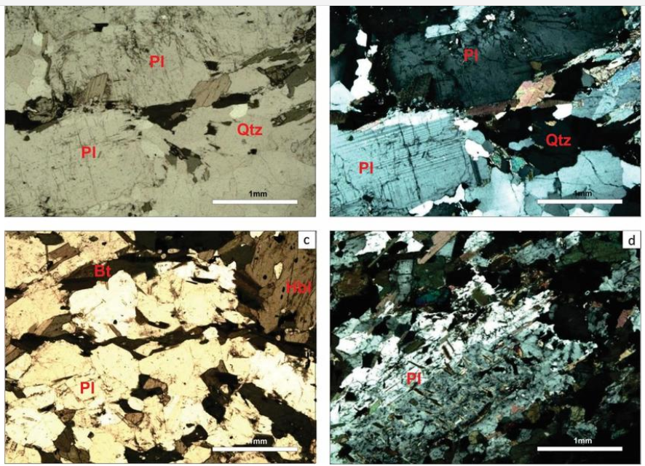

Microscopic aspects of the Werekitto gneisses and granitoids. (a) coarse-grained hornblende-biotite tonalitic rock, with a foliation defined by the orientation of the mafic components, such as biotite (Bt), and hornblende and tabular zoned plagioclase crystals (Pl). Thin section SB-24A, plane-polarized light. Scale = 1 mm. (b) Same image as previous under crossed polarizers. Thin section SB-24A. Scale= 1 mm. (c) Biotite (Bi)-hornblende (Hbl) quartz dioritic rock showing a gneissic structure. Thin section SB-22A plane-polarized light. Scale= 1mm. (d) Plagioclase (Pl) phenocryst with Carlsbad-albite twins in dioritic enclave. Thin section SB-24 B, crossed polarizers. Scale = 1 mm.

Sample 91. Biotite gneiss
Biotite gneiss is foliated metamorphic rock. XENOBLASTIC Gneissic rock with white and black bands of felsics and biotite, respectively. This rock is mostly composed of creamy-white feldspar and quartz, together with dark minerals, of which the most abundant is the dark mica biotite. The dark minerals are arranged in a streaky banding, giving the rock a gneissic texture. The flakes of mica are also aligned with their long dimensions parallel to the mineral banding. However, the rock is not fissile, i.e. it does not break easily along this direction. Therefore, despite its mica content, it would not be called a schist.

Quartzo-feldspathic matrix - 60%
Biotite: 40%

For more information:
https://www.earth.ox.ac.uk/~oesis/nws/nws-a98-9.html
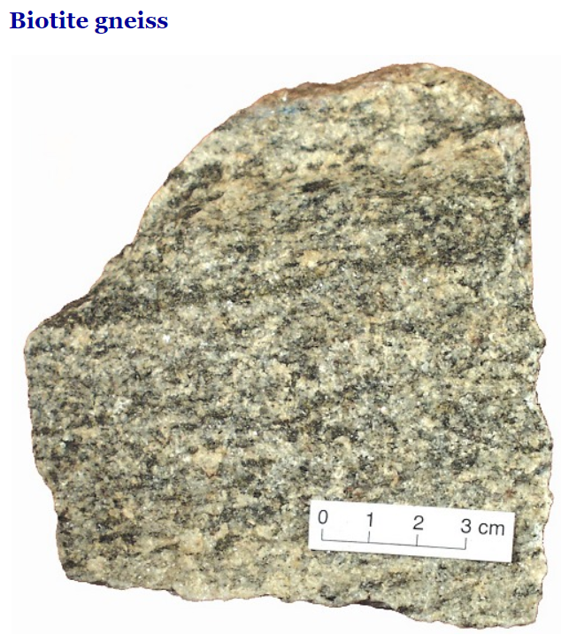
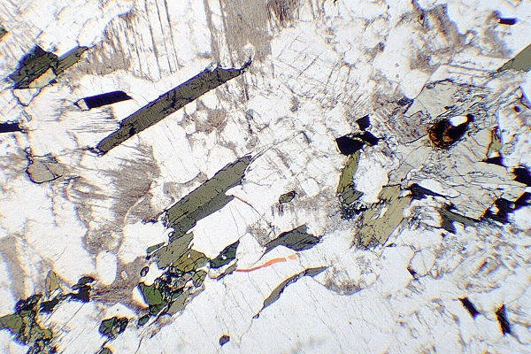
This gneiss contains essentially the same minerals as a granite but is distinguished at this scale from an unmetamorphosed igneous rock by the alignment of the dark minerals. The colourless minerals are quartz and feldspar, the feldspar appearing dusty with alteration. The elongate dark brownish minerals are biotite mica, and at lower left there is some greenish hornblende.
PPL, field of view 6 mm across
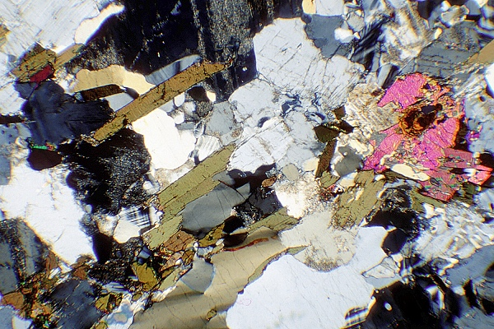
In this view, feldspars and quartz appear in shades of grey to black, while hornblende and biotite mica are brown and greenish-brown. The banding of the gneiss is apparent from the elongate shapes of the minerals, from top right to bottom left.
XPL, field of view 6 mm across

Sample 92. Eclogite
Eclogite is an extremely high-grade metamorphic rock. Eclogite is a high-pressure, moderate to high-temperature rock composed of garnet and green omphacite, a high-pressure Na-pyroxene. The rock is very dense (around 3.3 g/cm3). Eclogites often undergo alteration to amphibolites. Hornblende develops from the pyroxene, and is accompanied
by plagioclase. The amphibole may also be laucophane, instead of hornblende. Dense GRANOBLASTIC Pyrite - 2%, anh, bronze, 0.5 1.0 mm, flaky. One specimen: 15-20% garnet and has a dark green flaky mineral (7%) - probably a green mica. Less feldspar (5%) and omphacite (66-71%).

Garnet: 4%
Omphacite: 84%
For more information:
https://www.alexstrekeisen.it/english/meta/eclogite.php

https://www.youtube.com/watch?v=9DsNK7IMhvI

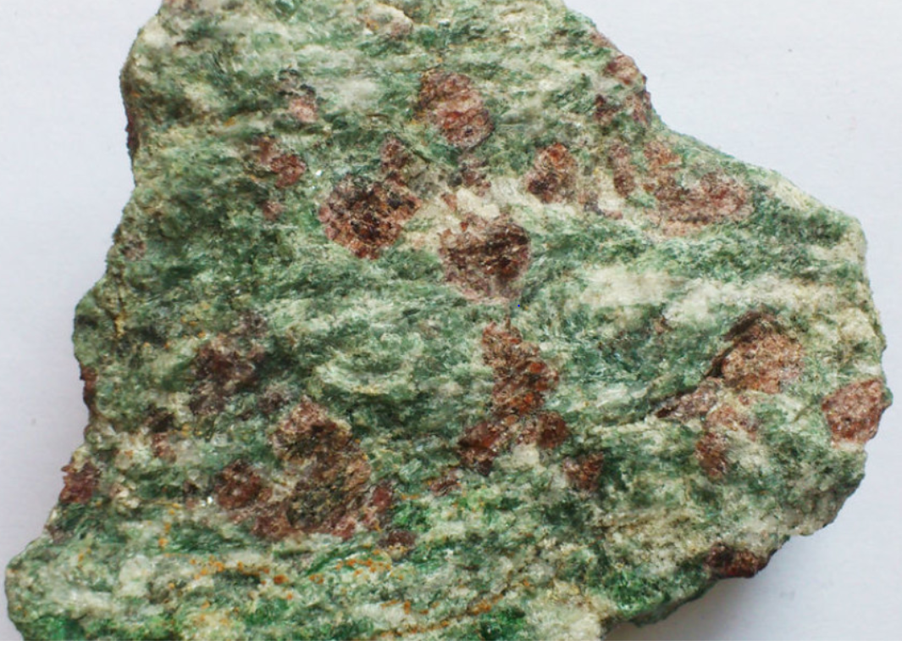

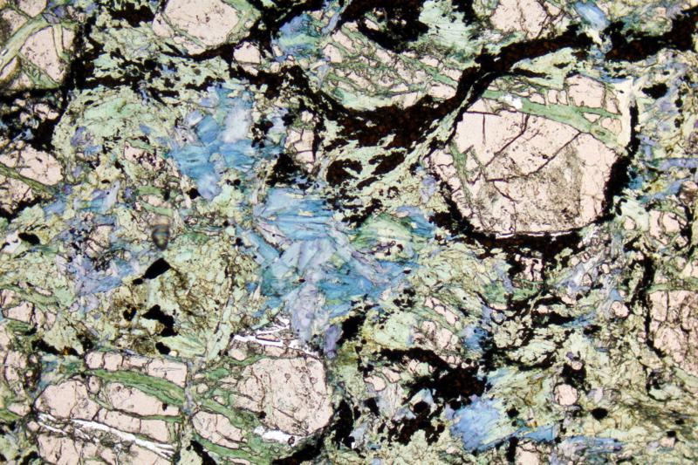
Garnet (pink, with chlorite alteration), rutile, Glaucophane (blue) and Omphacite (green) in an Eclogite. PPL image, 2x (Field of view = 7mm)
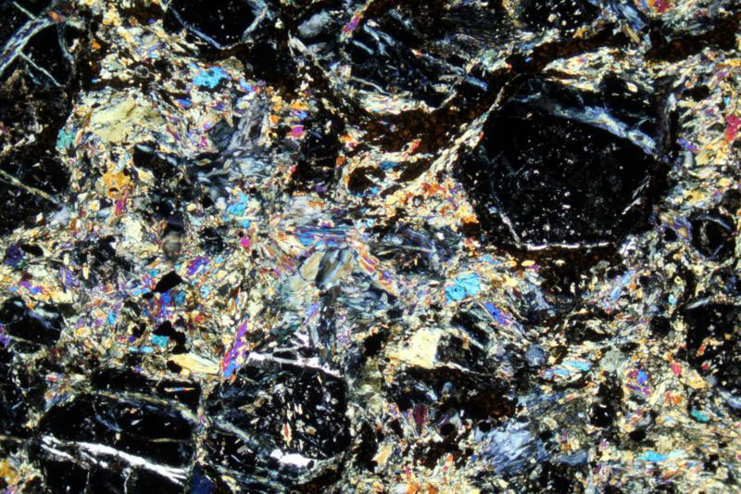
Garnet (isotropic, with chlorite alteration), rutile, Glaucophane and Omphacite in an Eclogite. XPL image, 2x (Field of view = 7mm)

Sample 97. Hornblende gneiss
Hornblende gneiss is a coarse-grained metamorphic rock belonging to the gneiss family, its overall dark colouration is due to high levels of the mafic mineral hornblende, while quartz and feldspar are also present. Fine grained Moderate gneissic layering.
Feldspar: 60-65% (plagioclase)
Hornblende: 35-40%

For more information:
https://www.youtube.com/watch?v=3MYRWe4BV0c
https://www.youtube.com/watch?v=1OdYmVq9r2g
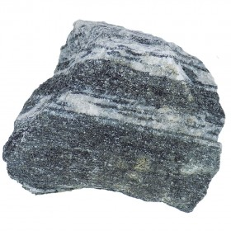

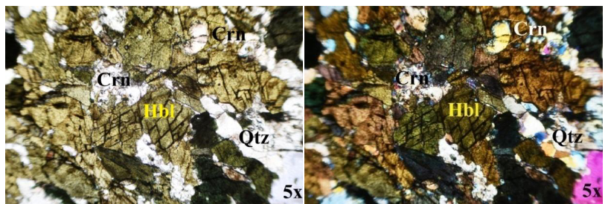

Hornblende gneiss under PPL and XPL

Other Metamorphic rocks

Sample 100. Grunerite-Magnetite
Sample 338. Amphibolite (https://www.alexstrekeisen.it/english/meta/amphibolite.php)
Piedmontite Gneiss (mineral properties of piemontite: https://www.alexstrekeisen.it/english/meta/piemontite.php)
Sample 352 Magnetite Gneiss: (https://www.researchgate.net/figure/Petrographic-features-of-magnetite-gneiss-in-the-Binga-iron-ore-prospect-a-b_fig5_301576719)

